Coming Up for Families
Christ Church Parbold – October
Sunday’s 4th & 12th October – 10:30am
Junior Church & Weekly Children’s Resources

Junior Church meets in the Scout Hut for ages 4–13. At the back of church each week we also have:-
• Tots’ Area (0–3yrs)
• Lending Library
• Resource Table with extra children’s activities
―――――――――――――――――――――――――――――――――――――――――――――


Sunday 11th October – 6:00pm
Soul Action Café (Youth)
Our relaxed faith-based youth group for Year 7+ which meets in the Scout Hut.
―――――――――――――――――――――――――――――――――――――――――――――

Sunday 18th October – 9:30am
Muddy Church at the Hut
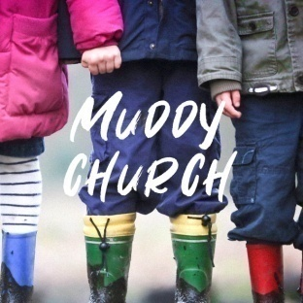
Fun outdoor craft activities exploring 'The Bible is God’s Word - The House on the Rock'. With house on the rock and water pistols, painted rock stones, LED Stickies, downloaded bible bookmarks, daily bread toast painting, slippy sand and oobleck slime, we’ll love God’s word with heart crystals art and there’ll be pencils to take home plus our usual Tots Table, s’mores & firepit. All ages welcome – dress to mess!
Well done to Kaylee B, Holly & Archie S, Henry B, Isla, Henry & Rosie R & Marnie who all 'Made It' round September’s Muddy Church bases.
For more details about our services, please contact Rev Sue: susanktimmins@aol.com

