Coming up for families in September at Christ Church Parbold

Sunday 6th September 930am: Family Service with Pop up Youth Band.
Everyone welcome to our lively and very interactive 30 minute service with music from our Pop up Youth Band and where the theme is ‘Praise God’


Sunday’s 13th & 27th September 6pm: Soul Action Café
Soul Action Cafe is our youth group for Year 7+ which meets in the Scout Hut.


Sunday 13th September 1030am: Junior Church and Weekly Children’s Resources Area.
Whilst Junior Church meets in the Scout Hut and is for 4-13yrs, we also have at the back of church, each week, a Tots’ Area, which is for 0-3yrs, as well as a Lending Library and for the older one’s there’s the Resource Table, with extra children’s activities.
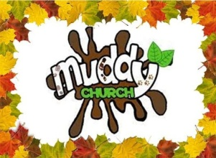
Sunday 20th September 930am: Muddy Church at the Hut. We’re at the Hut for an hour of fun and outdoor craft activities, where this time we’ll be thanking God for the Harvest with a wheelbarrow race, thank you cards and grass hearts making (to take home) tree rubbing, leaf bashing, dancing beans, thank you heart growing cress, and we'll be praying for others with sensory spice and cardboard box prayers. As well, there'll be our usual Special Tots Table with treasure hunt matchboxes, s’more’s and more. All ages are welcome and we go ahead whatever the weather –Just turn up and Dress to Mess!

Sunday 20th September1030am: Family Worship and Holy Communion Service. Join us, if you can, for our Worship and Holy Communion service, which is for everyone.

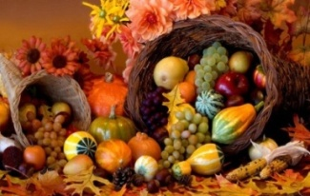
Sunday 27th September 1030am: All Age Harvest Festival Service with Pop up Youth Band.
Everyone is welcome to join us in church for our traditional Harvest Festival Service which is for all ages and included music from our Pop up Youth Band.
For more details about any of our services, please contact Rev Sue:- susanktimmins@aol.com

