
Coming Up for Families
Christ Church Parbold – November
Sunday’s 8th & 22nd November – 6:00pm
Soul Action Café (Youth)

Our youth group for Year 7+ which meets in the Scout Hut. ――――――――――――――――――――――――――――――――――――――――――――――――――
Sunday 8th November – 10:30am
All Age – Remembrance Day Service
Join us in Church for this special service where we will honour and remember those armed forces members who have lost their lives in the line of duty.

--- ――――――――――――――――――――――――――――――――――――――――――――――――――
Sunday 15th November – 9:30am
Muddy Church at the Hut
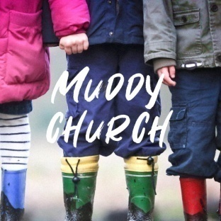
Fun outdoor craft activities where this time we'll have a Muddy Church Advent - 'Advent Saviour God is With Us' theme.
Activities include: splat painting, catapult art, a gunge tank, advent CD holders, glitter slime – God in the mess, Jesus star tree and handprint craft tree ornaments, pray for light in dark places fireworks. As well, there's our usual special Tots Table (sand tray sorry prayers), s’mores and firepit . All ages are very welcome and please dress to mess!
Well done to Archie & Holly S + Isla & Marnie L for completing all of October’s Muddy Church bases.
――――――――――――――――――――――――――――――――――――――――――――――――――
Sunday’s 22nd November – 10:30am
Junior Church & Weekly Children’s Resources


Junior Church meets in the Scout Hut for ages 4–13. At the back of church each week we also have:
• Tots’ Area (0–3yrs)
• Lending Library
• Resource Table with extra children’s activities ――――――――――――――――――――――――――――――――――――――――――――――――――

For more details about our services, please contact Rev Sue: susanktimmins@aol.com

